**FaceRec – User Manual**

Before following the steps, make sure you have below libraries already installed:

1. **Keras**
2. **OpenCV**
3. **Anaconda**

**Steps to Follow:**

1. Extract the **FaceRec.zip** file in the destination folder (**C:\Users\shivanand.roy\Documents**).

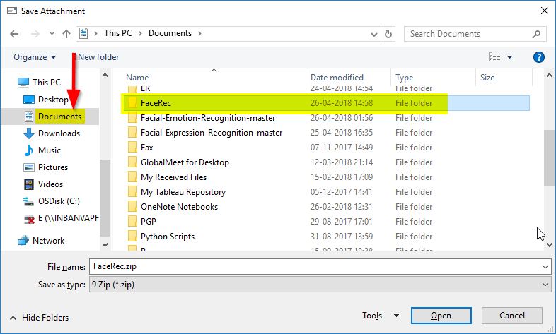

1. Open Anaconda Prompt. (Start 🡪 type Anaconda Prompt🡪Enter)

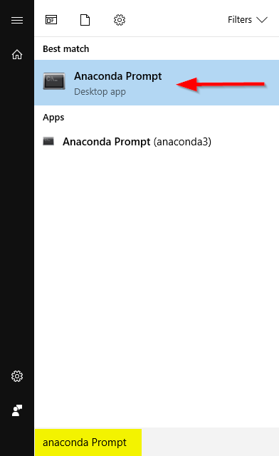

1. Wait till Anaconda Prompt terminal opens up.

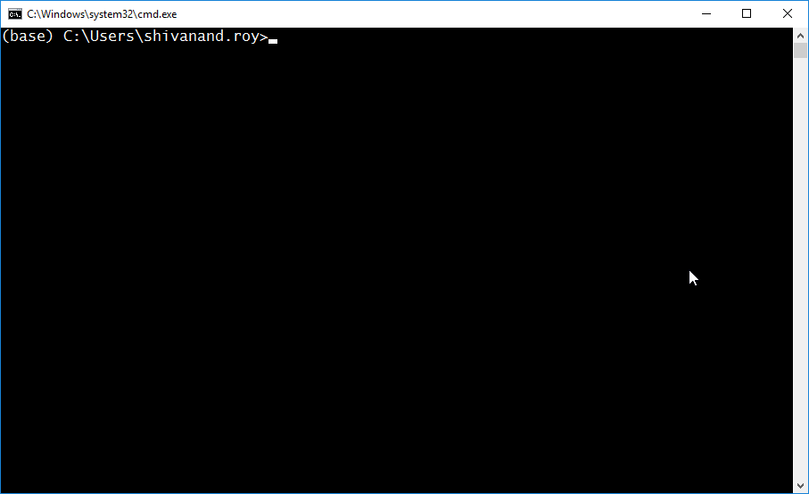

1. Change the current directory to FaceRec folder *C:\Users\shivanand.roy\Documents\FaceRec*).

Command: ***cd C:\Users\shivanand.roy\Documents\FaceRec***

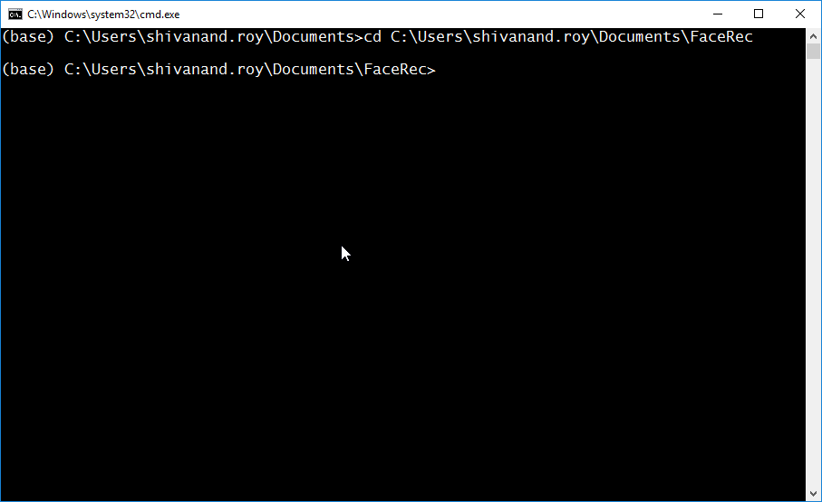

1. Once in the FaceRec folder, run real_time_emotion_recognition.py file.

Command: ***python real_time_emotion_recognition.py***

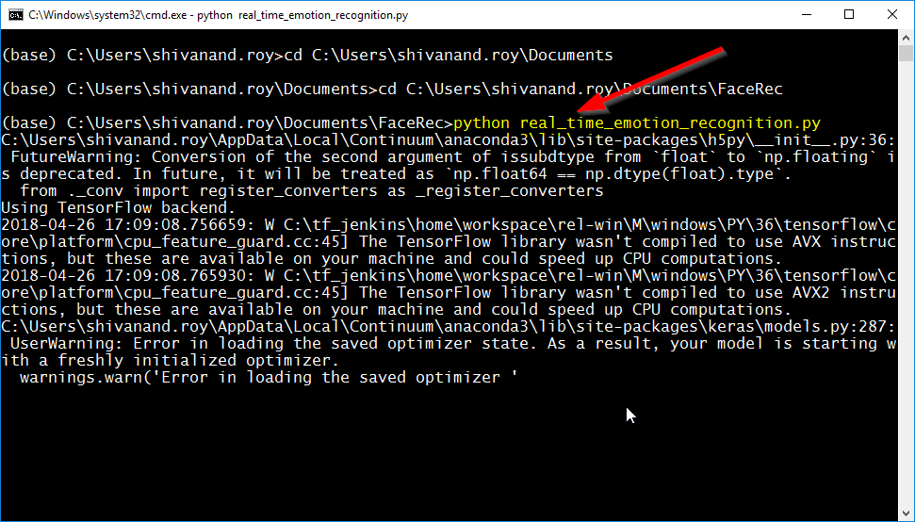

1. After running the ***real_time_emotion_recognition.py*** file, web cam will automatically fire up and we’re ready to classify human emotions in real time.

**Demo**

